Lab 2: Oracle DML Operations – Insert, Update, Select, Delete
Date: 02/11/2025

Objectives
Learn to insert new records into tables.
Learn to update existing records.
Learn to retrieve data using SELECT.
Learn to delete records from tables.

Tools
Oracle Database XE
SQL Developer
Docker

Steps

1. INSERT Operations
General Syntax:
INSERT INTO table_name (column1, column2, ...)
VALUES (value1, value2, ...);
Example:
Add a new region
INSERT INTO regions (region_id, region_name)
VALUES (51, 'Arctic Region');

Add a new country
INSERT INTO countries (country_id, country_name, region_id)
VALUES ('NP', 'Nepal', 16);

COMMIT;

2. UPDATE Operations
General Syntax:
UPDATE table_name
SET column1 = new_value1, column2 = new_value2, ...
WHERE condition;
Example:
Update the newly inserted region name
UPDATE regions
SET region_name = 'Arctic and Polar Region'
WHERE region_id = 51;

Update the country to belong to a different region
UPDATE countries
SET region_id = 48
WHERE country_id = 'NP';

COMMIT;

3. SELECT (Read) Operations
General Syntax:
SELECT column1, column2, ...
FROM table_name
WHERE condition;
Example:
Retrieve all countries
SELECT * FROM countries;

4. DELETE Operations
General Syntax:
DELETE FROM table_name
WHERE condition;
Example:
Delete the newly inserted country
DELETE FROM countries
WHERE country_id = 'NP';

Delete the newly inserted region
DELETE FROM regions
WHERE region_id = 51;

COMMIT;

- Insert
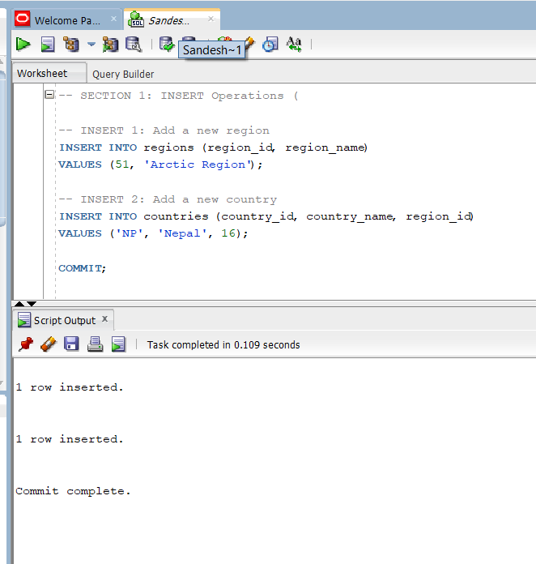

- Update
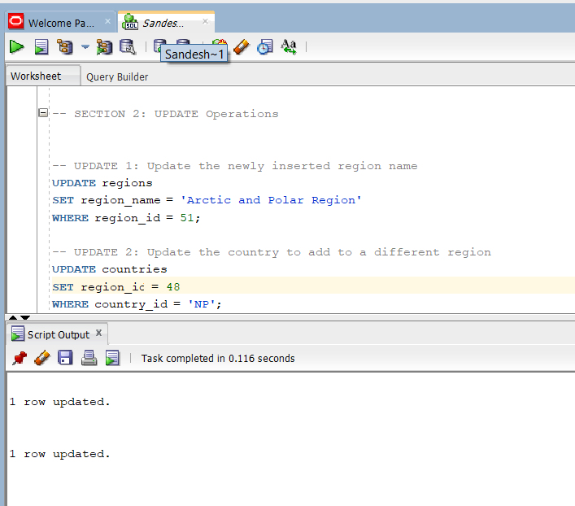

- Read
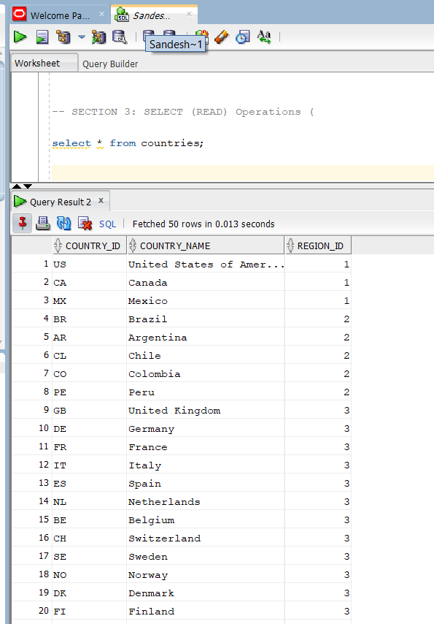

- Delete
